Analysis document of
Private Clinic System

Version 1.1

Students:
23521476 – Đặng Phú Thiện
23520952 – Phan Lê Minh
23520658 – Bùi Thị Phương Huyền
22520128 – Đặng Lê Bình

Document change record sheet

Date | Version | Description | Authors
17/10/2005 | 1.1 | …………………………………… | ……………………..

Table of contents

1. Class diagram (Analysis level) 3
1.1 List of related entity classes 3
1.2 Conceptual model 4
1.3 Class diagram (Analysis level) 6
1.4 List of classes and relationships 8
1.5 Details of the classes 10
2. State diagram 19
3. Dynamic model (dynamic model) 27

Class diagram (Analysis level)

List of related entity classes
• Account
• Patient
• Staff (parent)
• Doctor (inherits Staff)
• Receptionist (inherits Staff)
• Warehouse Staff (inherits Staff)
• Admin (inherits Staff)
• Appointment
• Reception
• Medical Record
• Prescription
• Medicine
• Medicine Price
• Prescription Detail
• Medicine Import
• Import Detail
• Medicine Inventory
• Service
• Invoice
• Invoice Medicine Detail (composition under Invoice)
• Invoice Service Detail (composition under Invoice)
• Staff Schedule

Conceptual model
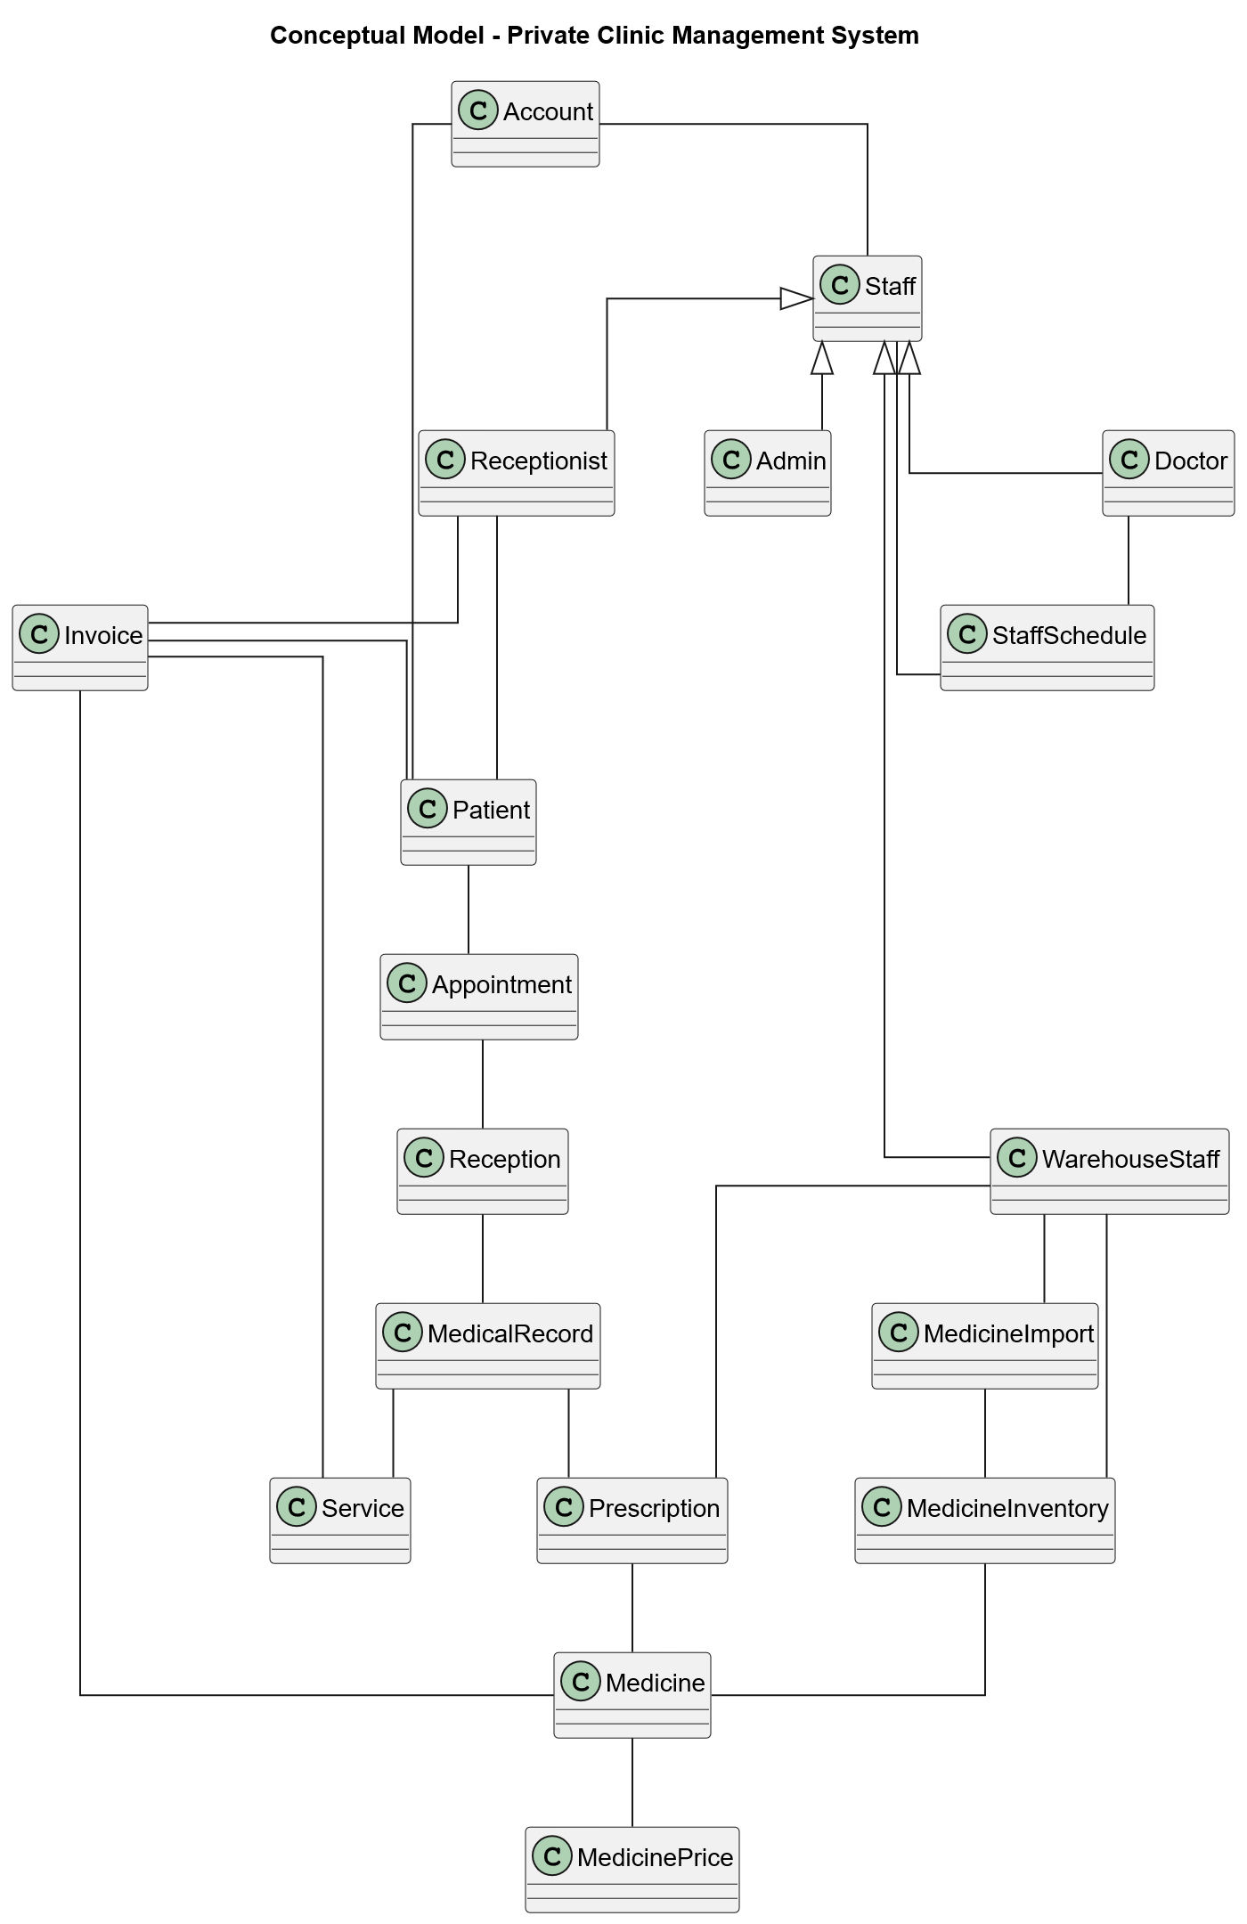

Class diagram (Analysis level)
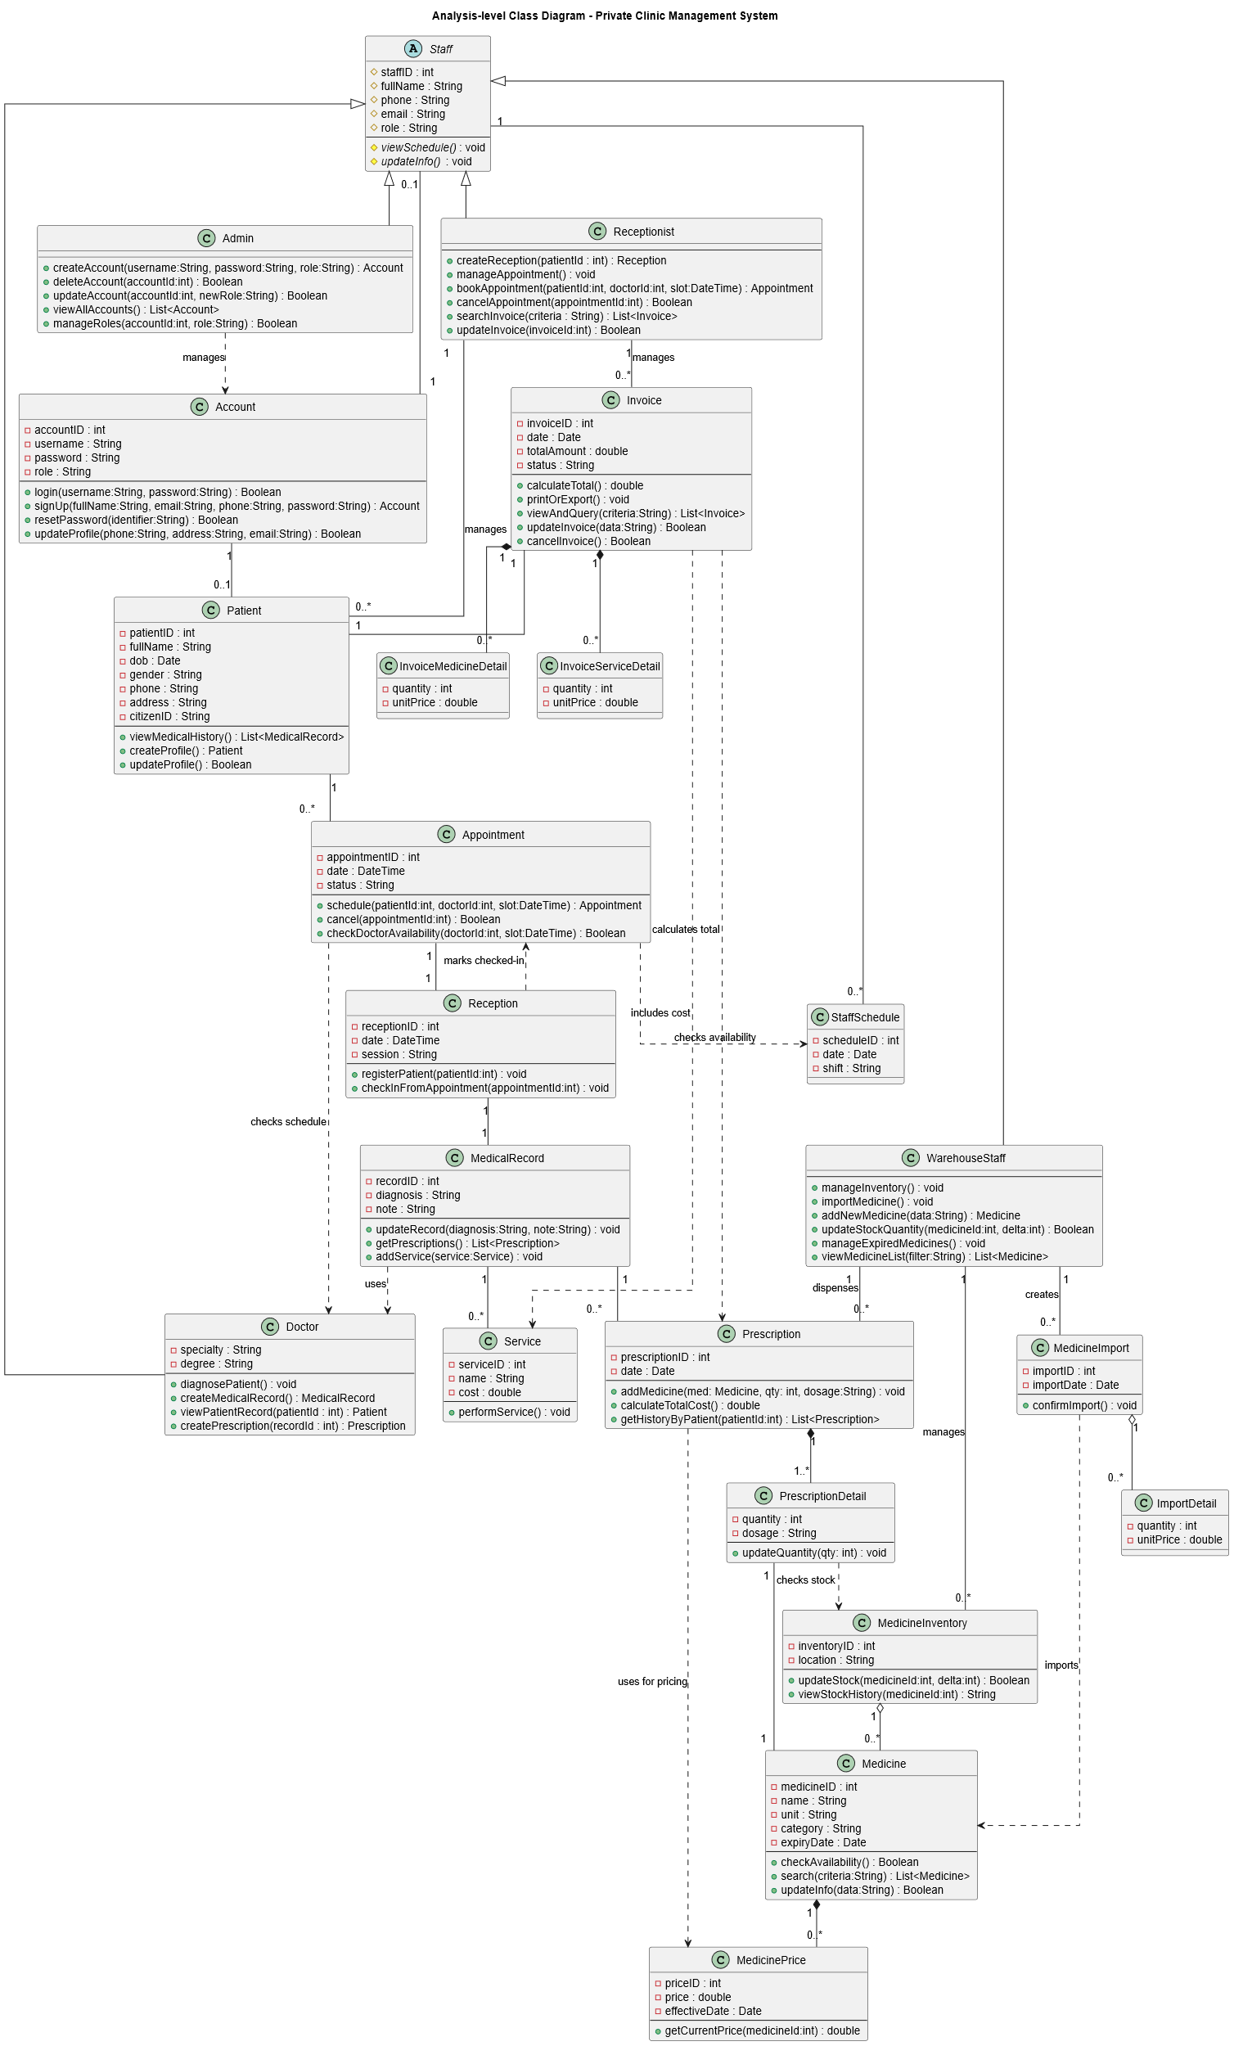

List of classes and relationships
.No | Class | Type  (Entity/ Boudary/ Control) | Note
1 | Account | Entity | Manages login credentials and permissions for staff.
2 | Staff (abstract) | Entity | Abstract parent class for different types of staff.
3 | Doctor (extends Staff) | Entity | Inherits from Staff, directly examines patients and creates prescriptions.
4 | Receptionist (extends Staff) | Entity | Inherits from Staff, manages reception and appointments.
5 | WarehouseStaff (extends Staff) | Entity | Inherits from Staff, manages the medicine warehouse.
6 | Admin (extends Staff) | Entity | Inherits from Staff, handles system administration and configuration.
7 | Patient | Entity | Stores patient information.
8 | Appointment | Entity | Records an appointment booked by a patient.
9 | Reception | Entity | Records the patient check-in event (when they arrive).
10 | MedicalRecord | Entity | Stores the patient's medical records.
11 | Prescription | Entity | Records a prescription issued by a doctor.
12 | PrescriptionDetail | Entity | Detail (association class) of a prescription, specifying a medicine.
13 | Medicine | Entity | Stores information about a specific medicine.
14 | MedicinePrice | Entity | Manages medicine pricing (can be historical or current).
15 | MedicineImport | Entity | Records a medicine import slip for the warehouse.
16 | ImportDetail | Entity | Detail (association class) of an import slip.
17 | MedicineInventory | Entity | Manages the stock quantity (inventory) of medicine.
18 | Service | Entity | Stores information about a medical service (e.g., X-ray, lab test).
19 | Invoice | Entity | The patient's payment invoice.
20 | InvoiceMedicineDetail | Entity | Detail (association class) listing medicines on the invoice.
21 | InvoiceServiceDetail | Entity | Detail (association class) listing services on the invoice.
22 | StaffSchedule | Entity | Manages the working schedule or shifts for staff members.

Details of the classes

Class: Account
Inheritance: None
Relationships: Association with Patient, Staff
Description: User account used for authentication/authorization of staff and patients.
No. | Attribute name | Type | Constraints | Description/Notes
1 | accountID | int | private | Primary identifier
2 | username | String | private | Unique username
3 | password | String | private | Hashed password
4 | role | String | private | Role (Admin/Staff/Patient)
Main Methods
- login(username:String, password:String) : Boolean – authenticate user
- signUp(fullName:String, email:String, phone:String, password:String) : Account – register account
- resetPassword(identifier:String) : Boolean – reset password
- updateProfile(phone:String, address:String, email:String) : Boolean – update profile

Class: Staff (abstract)
Inheritance: None
Relationships: Association with Account, StaffSchedule
Description: Abstract employee of the clinic.
No. | Attribute name | Type | Constraints | Description/Notes
1 | staffID | int | private | Staff ID
2 | fullName | String | private | Name
3 | phone | String | private | Phone number
4 | email | String | private | Email
5 | role | String | private | Position/role
Main Methods
- viewSchedule() : void – view own working schedule
- updateInfo() : void – update staff information

Class: Doctor (extends Staff)
Inheritance: Staff
Relationships: Association with Appointment; Dependency with Appointment (checks schedule); Dependency with MedicalRecord (used by)
Description: Medical staff responsible for diagnosis and prescriptions.
No. | Attribute name | Type | Constraints | Description/Notes
1-5 | (Inheritance) |  | protected | Inherits from Staff
6 | specialty | String | private | Doctor’s specialty
7 | degree | String | private | Qualification
Main Methods
- diagnosePatient() : void – perform diagnosis
- createMedicalRecord() : MedicalRecord – create a new record
- viewPatientRecord(patientId:int) : Patient – retrieve patient data
- createPrescription(recordId:int) : Prescription – generate prescription

Class: Receptionist (extends Staff)
Inheritance: Staff
Relationships: Association with Patient, Invoice
Description: Handles patient reception, appointment booking, and invoices.
No. | Attribute name | Type | Constraints | Description/Notes
1-5 | (Inheritance) |  | protected | Inherits from Staff
Main Methods
- createReception(patientId:int) : Reception – register patient arrival
- manageAppointment() : void – manage appointment list
- bookAppointment(patientId:int, doctorId:int, slot:DateTime) : Appointment – schedule appointment
- cancelAppointment(appointmentId:int) : Boolean – cancel appointment
- searchInvoice(criteria:String) : List<Invoice> – search invoices
- updateInvoice(invoiceId:int) : Boolean – modify invoice

Class: WarehouseStaff (extends Staff)
Inheritance: Staff
Relationships: Association with Prescription, MedicineImport, MedicineInventory
Description: Manages medicine imports, stock, and inventory.
No. | Attribute name | Type | Constraints | Description/Notes
1-5 | (Inheritance) |  | protected | Inherits from Staff
Main Methods
- manageInventory() : void – manage stock
- importMedicine() : void – handle import
- addNewMedicine(data:String) : Medicine – register medicine
- updateStockQuantity(medicineId:int, delta:int) : Boolean – update stock
- manageExpiredMedicines() : void – handle expired stock
- viewMedicineList(filter:String) : List<Medicine> – search medicine

Class: Admin (extends Staff)
Inheritance: Staff
Relationships: Dependency with Account (manages)
Description: System administrator managing accounts and roles.
No. | Attribute name | Type | Constraints | Description/Notes
1-5 | (Inheritance) |  | protected | Inherits from Staff
Main Methods
- createAccount(username:String, password:String, role:String) : Account – create new account
- deleteAccount(accountId:int) : Boolean – delete account
- updateAccount(accountId:int, newRole:String) : Boolean – change role
- viewAllAccounts() : List<Account> – view all accounts
- manageRoles(accountId:int, role:String) : Boolean – assign role

Class: Patient
Inheritance: None
Relationships: Association with Account, Appointment, Invoice

Description: Patient receiving services and treatments.
No. | Attribute name | Type | Constraints | Description/Notes
1 | patientID | int | private | Patient ID
2 | fullName | String | private | Name
3 | dob | Date | private | Date of birth
4 | gender | String | private | Gender
5 | phone | String | private | Phone
6 | address | String | private | Address
7 | citizenID | String | private | National ID
Main Methods
- viewMedicalHistory() : List<MedicalRecord> – view history
- createProfile() : Patient – create patient profile
- updateProfile() : Boolean – update info

Class: Appointment
Inheritance: None
Relationships: Association with Patient, Reception; Dependency with Doctor (checks schedule); Dependency with StaffSchedule (checks availability)

Description: Booking record connecting a patient with a doctor for a specific time slot.
No. | Attribute name | Type | Constraints | Description/Notes
1 | appointmentID | int | private | Appointment identifier
2 | date | DateTime | private | Date and time of appointment
3 | status | String | private | Status (Scheduled/Cancelled)
Main Methods
- schedule(patientId:int, doctorId:int, slot:DateTime) : Appointment – create appointment
- cancel(appointmentId:int) : Boolean – cancel appointment
- checkDoctorAvailability(doctorId:int, slot:DateTime) : Boolean – check doctor availability

Class: Reception
Inheritance: None
Relationships: Association with Appointment, MedicalRecord;
Dependency with Appointment (marks checked-in).
Description: Reception record when a patient checks in for service.
No. | Attribute name | Type | Constraints | Description/Notes
1 | receptionID | int | private | Reception identifier
2 | date | DateTime | private | Reception date
3 | session | String | private | Reception session or shift
Main Methods
- registerPatient(patientId:int) : void – register patient at reception
- checkInFromAppointment(appointmentId:int) : void – check in patient from appointment

Class: MedicalRecord
Inheritance: None
Relationships: Association with Reception, Prescription, Service; Dependency with Doctor (uses)

Description: Medical examination record containing diagnosis, services, and prescriptions.
No. | Attribute name | Type | Constraints | Description/Notes
1 | recordID | int | private | Record identifier
2 | diagnosis | String | private | Diagnosis details
3 | note | String | private | Additional notes
Main Methods
- updateRecord(diagnosis:String, note:String) : void – update diagnosis
- getPrescriptions() : List<Prescription> – list prescriptions
- addService(service:Service) : void – attach service to record

Class: Prescription
Inheritance: None
Relationships: Composition with PrescriptionDetail; Dependency with MedicinePrice (uses for pricing)
Description: A set of medicines prescribed to a patient.
No. | Attribute name | Type | Constraints | Description/Notes
1 | prescriptionID | int | private | Prescription ID
2 | date | Date | private | Prescription date
Main Methods
- addMedicine(med:Medicine, qty:int, dosage:String) : void – add medicine item
- calculateTotalCost() : double – calculate total cost
- getHistoryByPatient(patientId:int) : List<Prescription> – get prescription history

Class: PrescriptionDetail
Inheritance: None
Relationships: Association with Medicine; Dependency with MedicineInventory (checks stock)
Description: Represents a medicine line item in a prescription.
No. | Attribute name | Type | Constraints | Description/Notes
1 | quantity | int | private | Quantity prescribed
2 | dosage | String | private | Dosage instruction
Main Methods
- updateQuantity(qty:int) : void – update quantity prescribed

Class: Medicine
Inheritance: None
Relationships: Composition with MedicinePrice
Description: Medicine available in the clinic’s inventory.
No. | Attribute name | Type | Constraints | Description/Notes
1 | medicineID | int | private | Medicine ID
2 | name | String | private | Medicine name
3 | unit | String | private | Unit of measurement
4 | category | String | private | Medicine category
5 | expiryDate | Date | private | Expiry date
Main Methods
- checkAvailability() : Boolean – check stock availability
- search(criteria:String) : List<Medicine> – search for medicines
- updateInfo(data:String) : Boolean – update medicine info

Class: MedicinePrice
Inheritance: None
Relationships: Association with Medicine
Description: Time-based pricing for a specific medicine.
No. | Attribute name | Type | Constraints | Description/Notes
1 | priceID | int | private | Price ID
2 | price | double | private | Unit price
3 | effectiveDate | Date | private | Effective date of price
Main Methods
- getCurrentPrice(medicineId:int) : double – retrieve current price

Class: MedicineImport
Inheritance: None
Relationships: Composition with ImportDetail; Dependency with Medicine (imports)
Description: Record of medicine import transactions.
No. | Attribute name | Type | Constraints | Description/Notes
1 | importID | int | private | Import ID
2 | importDate | Date | private | Date of import
Main Methods
- confirmImport() : void – finalize import transaction

Class: ImportDetail
Inheritance: None
Relationships: Association with MedicineImport, Medicine
Description: Line item in a medicine import batch.
No. | Attribute name | Type | Constraints | Description/Notes
1 | quantity | int | private | Quantity imported
2 | unitPrice | double | private | Price per unit
Main Methods (None at analysis level)

Class: MedicineInventory
Inheritance: None
Relationships: Aggregation with Medicine
Description: Current stock details of a medicine lot.
No. | Attribute name | Type | Constraints | Description/Notes
1 | inventoryID | int | private | Inventory ID
2 | location | String | private | Storage location
Main Methods
- updateStock(medicineId:int, delta:int) : Boolean – update stock quantity
- viewStockHistory(medicineId:int) : String – view stock history

Class: Service
Inheritance: None
Relationships: Association with MedicalRecord
Description: Medical service provided by the clinic.
No. | Attribute name | Type | Constraints | Description/Notes
1 | serviceID | int | private | Service ID
2 | name | String | private | Service name
3 | cost | double | private | Service cost
Main Methods
- performService() : void – perform the service

Class: Invoice
Inheritance: None
Relationships: Composition with InvoiceMedicineDetail, InvoiceServiceDetail; Association with Patient; Dependency with Prescription (calculates total); Dependency with Service (includes cost)

Description: Billing document for a patient visit.
No. | Attribute name | Type | Constraints | Description/Notes
1 | invoiceID | int | private | Invoice ID
2 | date | Date | private | Invoice date
3 | totalAmount | double | private | Total amount billed
4 | status | String | private | Payment status
Main Methods
- calculateTotal() : double – calculate total amount
- printOrExport() : void – print or export invoice
- viewAndQuery(criteria:String) : List<Invoice> – search invoices
- updateInvoice(data:String) : Boolean – update invoice info
- cancelInvoice() : Boolean – cancel invoice

Class: InvoiceMedicineDetail
Inheritance: None
Relationships: Association with Invoice, Medicine
Description: Line item of medicine in an invoice.
No. | Attribute name | Type | Constraints | Description/Notes
1 | quantity | int | private | Quantity sold
2 | unitPrice | double | private | Unit price
Main Methods (None at analysis level)

Class: InvoiceServiceDetail
Inheritance: None
Relationships: Association with Invoice, Service
Description: Line item of a service in an invoice.
No. | Attribute name | Type | Constraints | Description/Notes
1 | quantity | int | private | Number of services
2 | unitPrice | double | private | Price per service
Main Methods (None at analysis level)

Class: StaffSchedule
Inheritance: None
Relationships: Association with Staff; Dependency with Appointment (checks availability)
Description: Work schedule assigned to staff.
No. | Attribute name | Type | Constraints | Description/Notes
1 | scheduleID | int | private | Schedule ID
2 | date | Date | private | Work date
3 | shift | String | private | Shift time or label
Main Methods (None at analysis level)

State diagram
Appointment state diagram
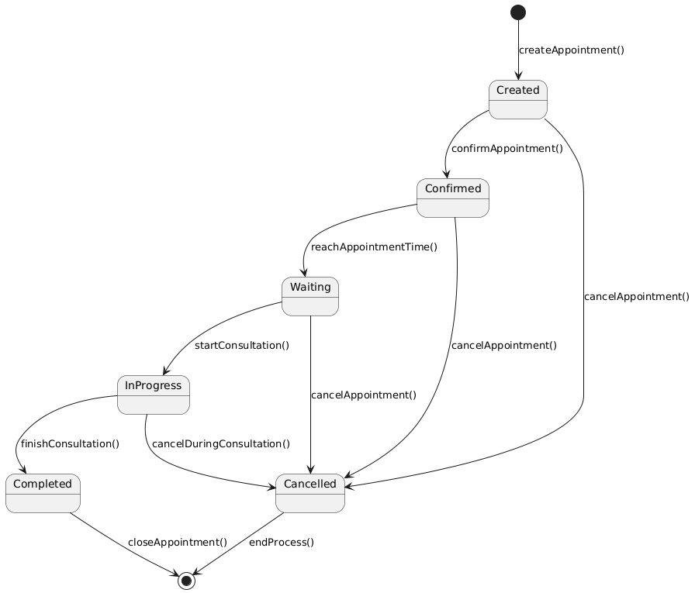
List of states
No | State
1 | Created
2 | Confirmed
3 | Waiting
4 | Cancelled
5 | InProgress
6 | Completed
List of envents
No | Events
1 | confirmAppointment()
2 | cancelAppointment()
3 | reachAppointmentTime()
4 | startConsulation()
5 | cancelDuringConsulation()
6 | finishConsulation()
7 | closeAppointment()
8 | endProcess()

Reception state diagram
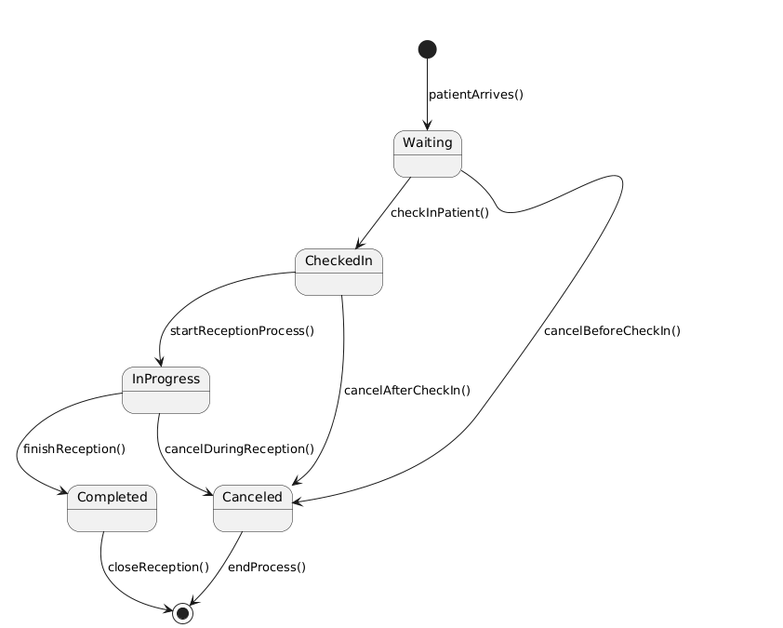
List of states
No | State
1 | Waiting
2 | CheckedIn
3 | InProgress
4 | Canceled
5 | Completed
List of envents
No | Event
1 | patientArrives()
2 | checkInPatient()
3 | cancelBeforeCheckIn()
4 | cancelAfterCheckIn()
5 | startReceptionProcess()
6 | cancelDuringReception()
7 | endProcess()
8 | closeReception()
9 | finishReception()
State diagram Medical Record
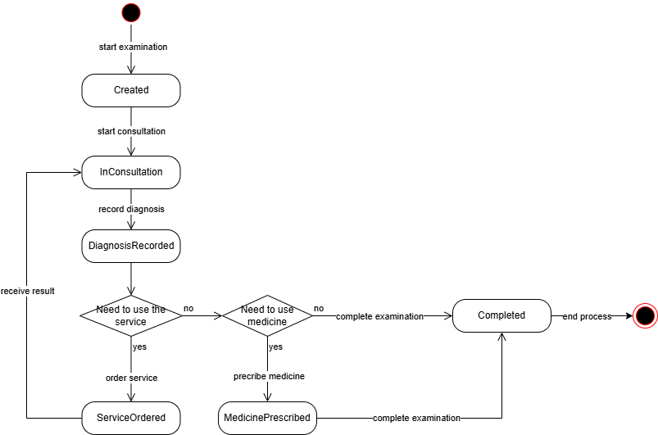
List of states
No | State
1 | Created
2 | InConsultation
3 | DiagnosisRecorded
4 | ServiceOrdered
5 | MedicinePrescribed
6 | Completed
List of events
No | Event
1 | start examination
2 | start consultation
3 | record diagnosis
4 | order service
5 | receive result
6 | prescribe medicine
7 | complete examination
8 | end process

State diagram Prescription
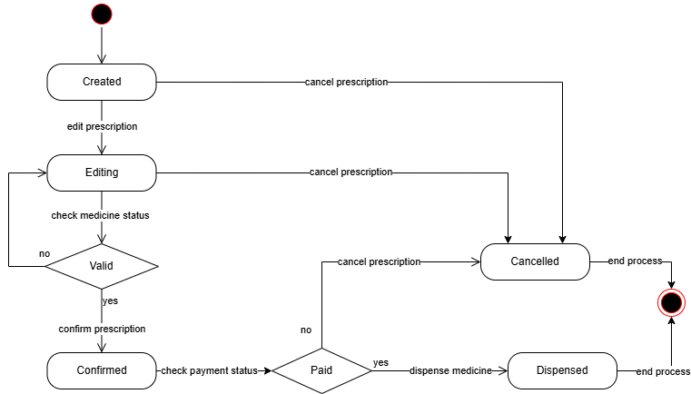
List of states
No | State
1 | Created
2 | Editing
3 | Confirmed
4 | Dispensed
5 | Cancelled
List of events
No | Event
1 | edit prescription
2 | check medicine status
3 | confirm prescription
4 | check payment status
5 | dispense medicine
6 | cancel prescription
7 | end process

Dynamic model (dynamic model)
Activity diagram for Book appointment
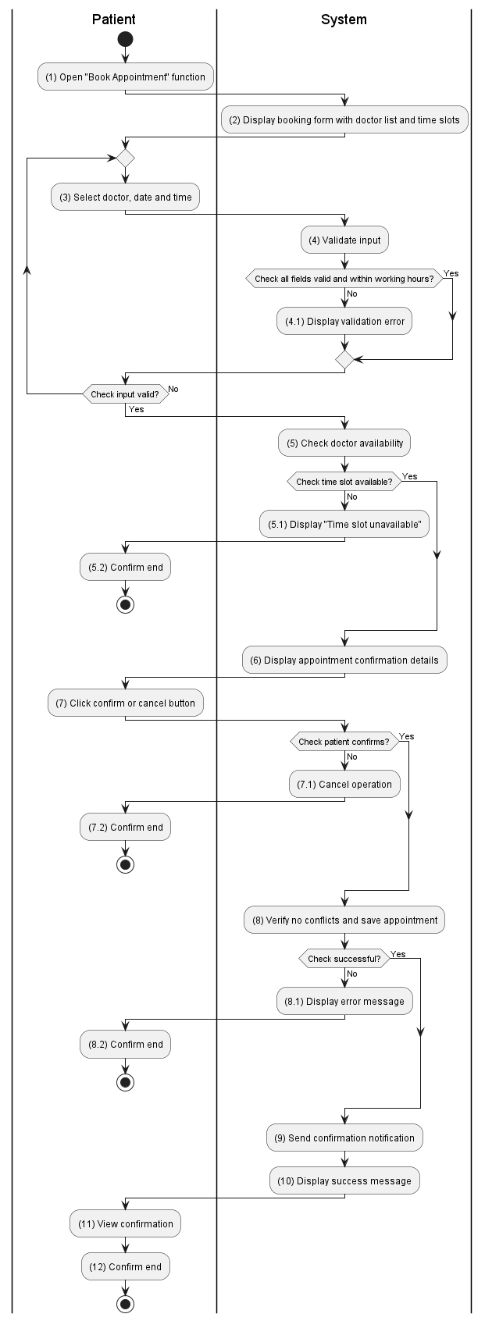

Activity diagram for Receive patient
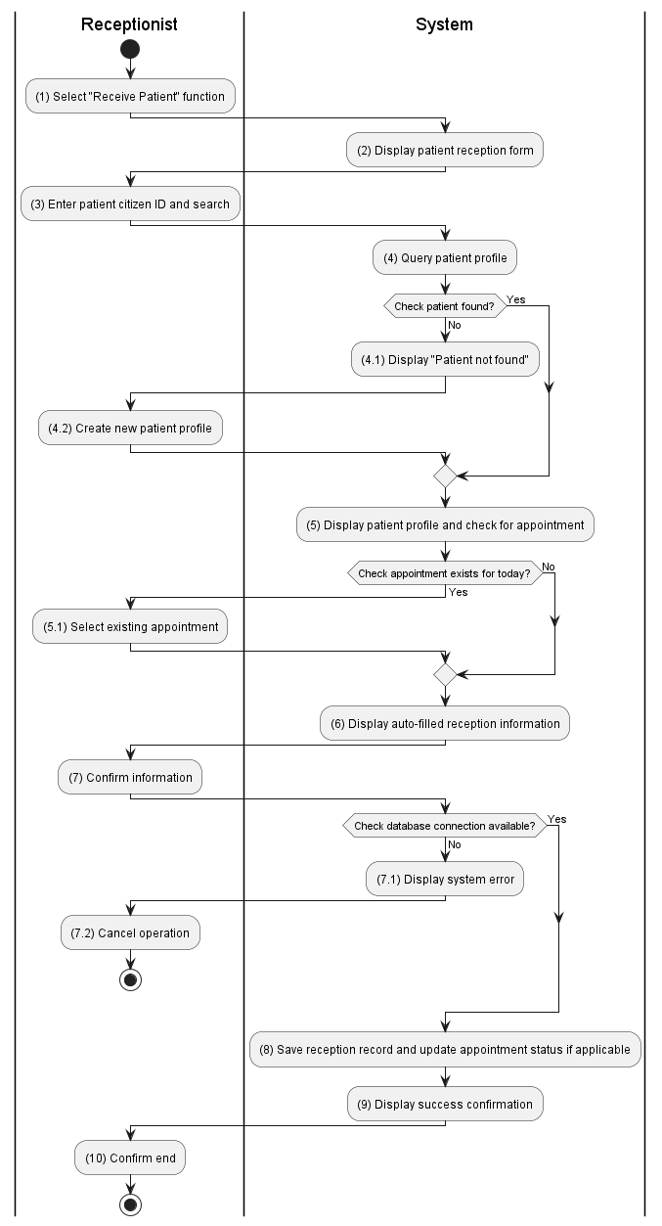

Activity diagram for Add new 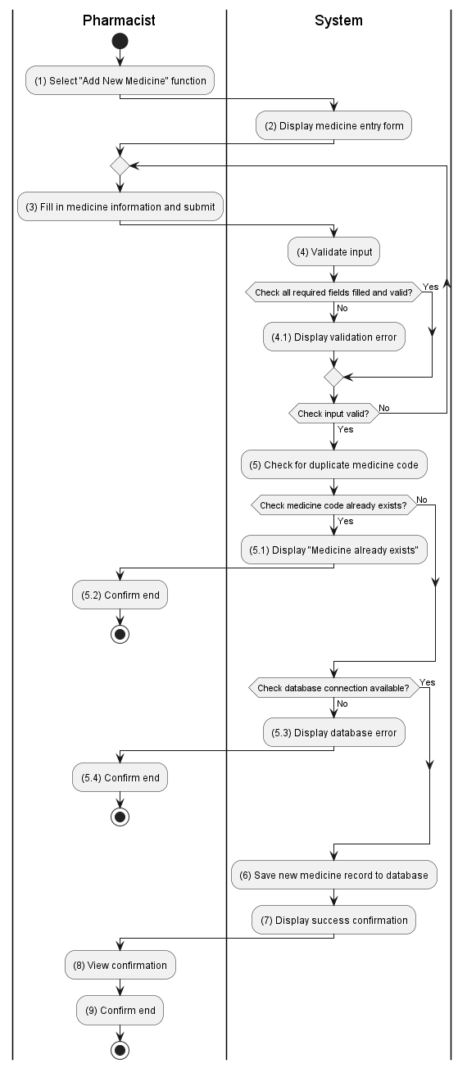Medicine

View Prescription History